5 Accessibility

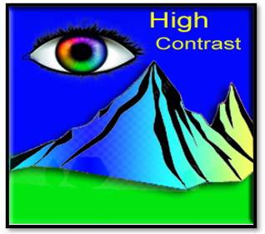

“In the land of interfaces, clarity is the highest peak—and contrast is the light that guides us there.”

# What is Accessibility?

Accessibility in programming is the practice of building applications or even websites, in a way that allows people with disabilities to use them. This involves (but is not limited to) providing text alternatives for images and widgets. You could also think about using colors with high contrast to help people even farther with other types of vision impediments.

# How to implement High Contrast Accessibility

For a tooltip, you really do not need the type of access that you would need for an image. An image needs text to explain itself, but a tool tip is basically a text container, but a really nice helper would be to supply a tooltip with high contrast. Here we have code that changes the background color to high yellow. This would help people with vision disabilities.

Here we put the high contrast code into a toggle button, so it can be switched on or off.

# Optional: Toggle high contrast mode

def toggle_contrast():

    current_bg = save_button.cget("bg")

    if current_bg == "lightgray":

        save_button.configure(bg="yellow", fg="black")

    else:

        save_button.configure(bg="lightgray", fg="black")

# Contrast toggle button

contrast_button = tk.Button(root, text="Toggle Contrast", command=toggle_contrast)

contrast_button.pack(pady=10)

# The Code

import tkinter as tk

from tooltip_magic.core import ToolTip

# Create the main window

root = tk.Tk()

root.title("Accessible Tooltip Demo")

root.geometry("400x300")

# Create a Save button using tk.Button

save_button = tk.Button(root, text="Save", bg="lightgray", fg="black")

save_button.pack(pady=40)

# Create the tooltip

tooltip_text = "Saves your progress"

tooltip = ToolTip(save_button, text=tooltip_text)

# Accessibility: Show tooltip on keyboard focus

def show_tooltip_on_focus(event):

    tooltip.showtip()

def hide_tooltip_on_blur(event):

    tooltip.hidetip()

save_button.bind("<FocusIn>", show_tooltip_on_focus)

save_button.bind("<FocusOut>", hide_tooltip_on_blur)

# Optional: Toggle high contrast mode

def toggle_contrast():

    current_bg = save_button.cget("bg")

    if current_bg == "lightgray":

        save_button.configure(bg="yellow", fg="black")

    else:

        save_button.configure(bg="lightgray", fg="black")

# Contrast toggle button

contrast_button = tk.Button(root, text="Toggle Contrast", command=toggle_contrast)

contrast_button.pack(pady=10)

root.mainloop()